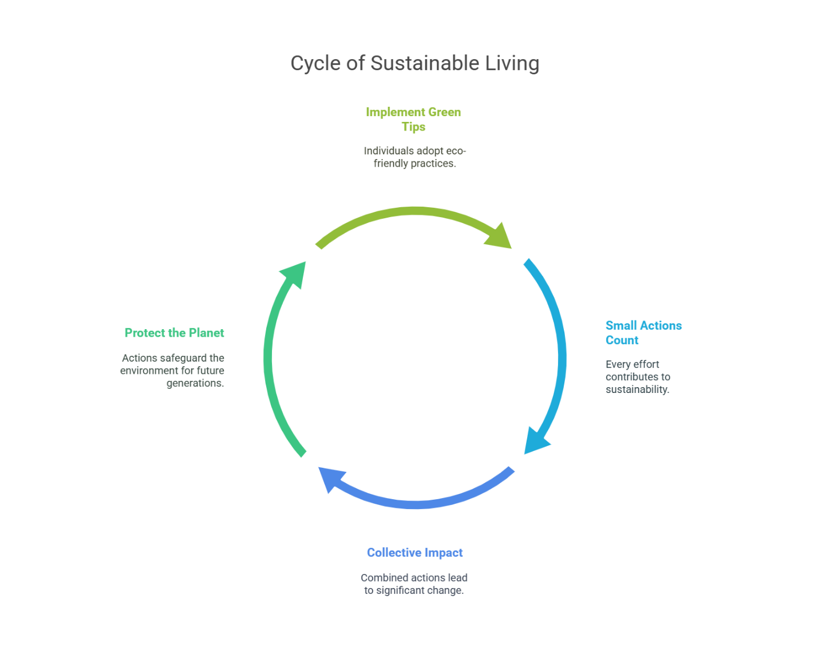

**Green Living Tips**

In an era where environmental concerns are at the forefront of global discussions, adopting a green lifestyle has never been more crucial. This document provides practical tips and strategies for individuals looking to reduce their ecological footprint and promote sustainability in their daily lives. From simple changes in household habits to more significant lifestyle adjustments, these tips aim to inspire and empower everyone to contribute to a healthier planet.

**1. Reduce, Reuse, Recycle**

* **Reduce**: Minimize waste by purchasing only what you need. Consider buying in bulk to reduce packaging waste.
* **Reuse**: Find new uses for items instead of discarding them. For example, glass jars can be repurposed for storage.
* **Recycle**: Familiarize yourself with your local recycling guidelines to ensure you are recycling correctly.

**2. Conserve Water**

* Fix leaks promptly to prevent water wastage.
* Use water-efficient fixtures, such as low-flow showerheads and faucets.
* Collect rainwater for gardening and outdoor use.

**3. Save Energy**

* Switch to energy-efficient appliances and LED light bulbs.
* Unplug electronics when not in use to avoid phantom energy consumption.
* Consider using a programmable thermostat to optimize heating and cooling.

**4. Choose Sustainable Transportation**

* Walk, bike, or use public transportation whenever possible to reduce carbon emissions.
* Carpool with friends or colleagues to decrease the number of vehicles on the road.
* If you drive, consider switching to an electric or hybrid vehicle.

**5. Support Local and Sustainable Products**

* Buy from local farmers' markets to reduce the carbon footprint associated with transporting goods.
* Choose products with minimal packaging and those made from sustainable materials.
* Support companies that prioritize environmentally friendly practices.

**6. Grow Your Own Food**

* Start a small garden to grow herbs, vegetables, or fruits. This reduces reliance on store-bought produce and minimizes packaging waste.
* If space is limited, consider container gardening or vertical gardening techniques.

**7. Reduce Meat Consumption**

* Incorporate more plant-based meals into your diet. Even one meatless day a week can make a difference.
* When consuming meat, opt for sustainably sourced options.

**8. Educate Yourself and Others**

* Stay informed about environmental issues and sustainable practices.
* Share your knowledge with friends and family to inspire them to adopt green habits.

**9. Practice Mindful Consumption**

* Before making a purchase, ask yourself if you truly need the item.
* Invest in quality products that last longer rather than cheap, disposable items.

**10. Get Involved**

* Join local environmental groups or initiatives to contribute to community sustainability efforts.
* Participate in clean-up events or tree-planting activities to make a tangible impact.

By implementing these green living tips, individuals can play a vital role in fostering a sustainable future. Every small action counts, and collectively, we can make a significant difference in protecting our planet for generations to come.